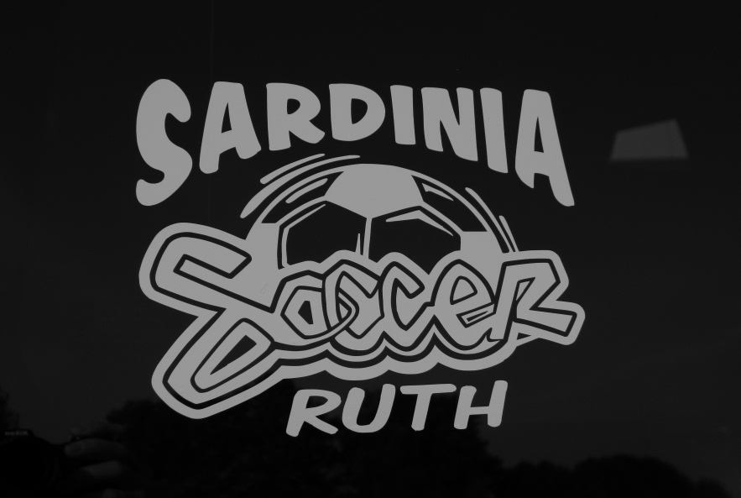
Sardinia Soccer Decal Sale
Decal Only $5.00
Personalized with 1 name $7.50
2 names $8.50
Must be paid in advance by Thursday Sept.5th
Please make checks payable to Sardinia Soccer.

Name Personalized Name Quantity Phone Number Total Cash/Ck#
Please Print Clearly!!!

