SKY RIVER U-5 PROGRAM
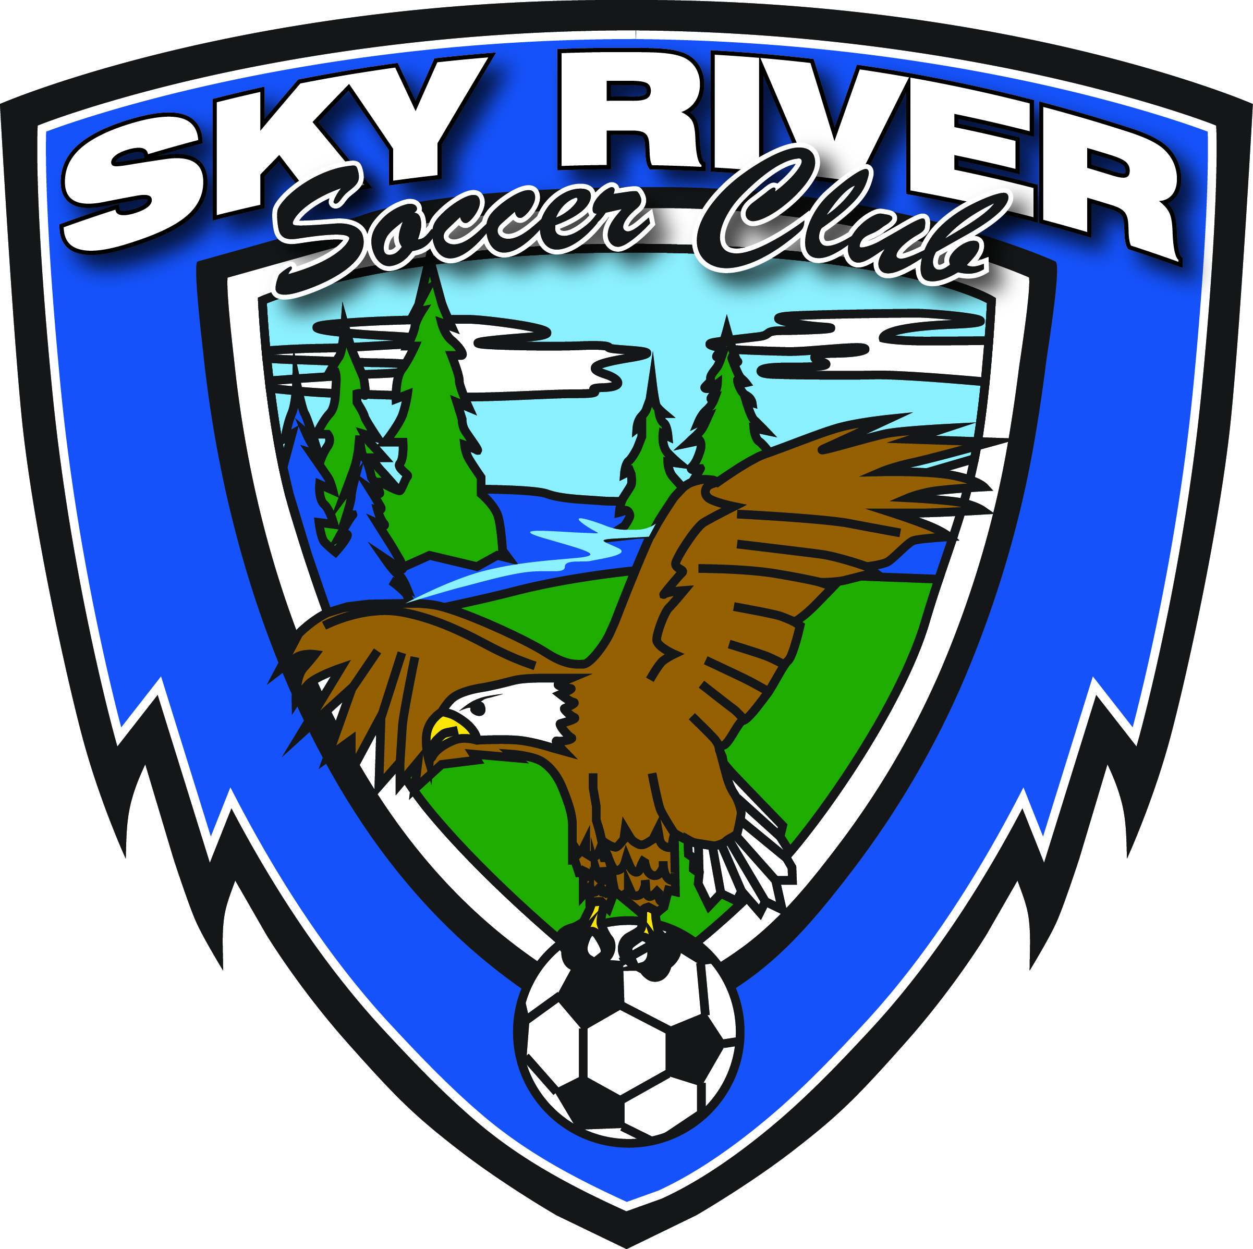 Rules for 2017
These rules may be changed periodically to meet player or coaching needs that may arise.
The objectives of the U-5 program are to:
HAVE FUN!
Learn the basics of soccer!
Learn the love of the game of soccer!
Make friends!
Improve the youth soccer program!

1. Field will be approximately 50 x 30 yards with markings for small goal area.

2. Teams will play with a #3 ball.

3. Player’s equipment: Appropriate footwear, i.e. tennis shoes, soft-cleats.
Shin guards are MANDATORY.

4. Teams will have equal number of players on the field, and will play 3 or 4-a-side with NO GOALIE.
Should a team not have three players, coaches are encouraged to “share” players. Team sizes must be
the same for game.

5. Maximum roster size will be 8 players. All players must be registered in order to play.

6. Games/practices will be scheduled from 12:00pm – 1:00 pm every Saturday for 8 weeks, beginning
Sept. 9; recommend one meet and greet/practice session just prior to start of season.

7. Teams will practice for approximately 20 minutes, then after a 5 minute break, will play a 20 minute game.
Attention span is short, keep practices simple. It is mandatory that all players be given the opportunity of 50%
playing time. Some may not want to play a lot but please encourage them to get out and try (even if mom/dad
or coach needs to hold their hand).

8. Start of Play: As soon as ball is touched and moves. Opponents must be eight (8) yards from the
center mark while kick-off is in progress.

9. There will be no referee. Coaches will be allowed to go on to the field to help players and explain fouls.
Substitutions may be made at any time.

10. Any fouls (handballs, pushing, tripping) will result in an in-direct free kick. Please explain to the player why the
foul was called.

11. Ball is out of play when it has wholly crossed the goal line or touch line whether on the ground or in the air.

12. Players will be given a second (and if necessary a 3rd) chance on throw-ins if the first is incorrect; instruct the player
the correct procedure.

13. Goal kicks and corner kicks are recommended; this can be difficult for young players to understand, but try to
teach it from the start.

14. No slide tackling will be allowed. There shall be no offside.

15. All players should be encouraged to make goals. There will be no scores kept, everyone wins! Encourage
parents to cheer even if your player scores in the wrong goal; or when the opponent scores.

16. There shall be no harassment of coaches or players, everyone is here for fun and to learn, we all make mistakes.
Parents are not allowed to coach from the sidelines, they are there as cheerleaders only.

17. Games will be played rain or shine. No games will be played during electrical storms. Canceled games will not be
re-scheduled.

18. Coaches and players shall shake hands after each game.

19. Heading: There will be no heading the ball in practice or games per USYSA mandate at this age.

20. Playing with casts or splints is prohibited.

Coaches Responsibility:
- Provide a safe and positive playing environment for his/her players.
- Shall encourage good sportsmanship at all times in words and action.
- Shall enforce appropriate and positive sideline behavior by all spectators on their sideline.
d) Shall assist with field preparation as needed at club request.
e) Shall assist club with enforcing all rules set forth by the club.
f) Shall ensure sideline is cleaned up after each game.

Club Responsibility:
- Provide a safe and positive playing environment for our players, coaches and spectators.
- Ensure fields are available for practices and games.
- Provide coaches with training materials/clinics. Recognizing that this may vary from season to season depending on the availability of volunteers, trainers and/or funds.
- Assist coaches with problems that can arise during league play; i.e., player discipline, sideline behavior.

The following rules/guideline shall be followed at all times:

1. No alcoholic beverages shall be consumed or used on or near the playing area.

2. No tobacco products shall be consumed or used near the playing area.

3. No illegal or controlled substances shall be consumed or used near the playing area.

4. No firearms or weapons of any kind shall be used or allowed near the playing area.

- No pets shall be allowed near the playing area at any time.

- For any issue not addressed here NCYSA/WYS/USYSA/FIFA rules will apply.

- The Sky River Soccer Club reserves the right to amend these rules as needed for the benefit of our club and membership.

