Sports Quest Prison Soccer Ministry
Match Day: Wednesday July 19, 2006 at Bastrop FCI (kick off 5.45 pm)

Match Analysis: Sports Quest entered the game with a depleted squad of only 13 players. Of these, four guests from Austin traveled to Bastrop for what proved to be a physically challenging and emotionally draining run out in temperatures nearing the hundred degree mark.

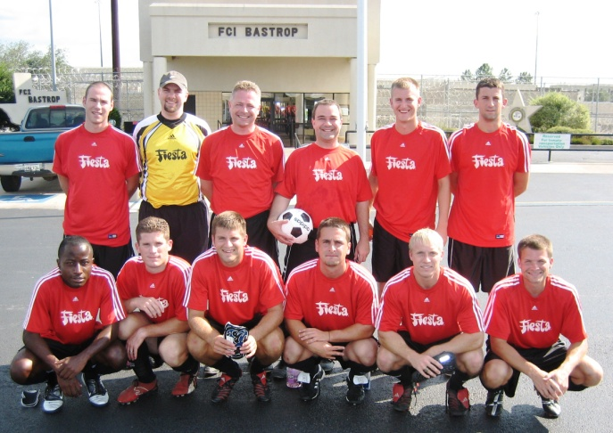
Greeted by jeers and a few cheers, Sports Quest dominated the opening exchanges. Midfielders Ambrosetti, Mullaney and Wells provided a pivotal link with the lively front running of Clarke and the defensive back four of Miller, Gunzelman and the two Frommel brothers. In goal, Weston looked confident and assured, though his noticeably smaller than normal goal box did create a few scary moments…

The opening goal came after fifteen minutes with Dove’s trickery proving a handful on the left wing. Awarded a free-kick just outside the box, Mullaney grappled the ball from his teammates and struck a low drive underneath the wall. The unsighted keeper threw himself across his goal-line only to dive over the top of the ball, allowing a “trickler” to put Sports Quest one up. Bastrop hit back following a flurry of substitutions from Sports Quest. Unorganized and undisciplined, the back line conceded space at the heart of the defense and was duly punished, albeit against the run of play.

Clarke restored the lead with an outstanding “curler” around the advancing Bastrop keeper, but before the half ended, scores were leveled when another defensive calamity gifted an equalizer to the inmate team.

Adjusting from a 4-3-3 to a 4-4-2 formation, Sports Quest started the second half in impressive form. “Pass and move” became the order of the day, and for a twenty minute spell, the level of soccer was very impressive indeed. Clarke hit home again following good work down the right wing from Trussell, and victory looked to be on the cards until the old enemy “fatigue” reared its ugly head. Players hit the ground with disturbing regularity, and cramp became an adversary out of control. First Mullaney, then Gunzelman, then Spence and finally Wells fell victim to overheating, (or was it “overeating?”), exhaustion and injury. The “pass and move” game now became “kick the ball as far as you can out of bounds and pray for full time” game. Alas, the tactic failed to fend off the Bastrop Boys, and with ten minutes remaining, the scores were leveled when a memorable strike from 20 yards eluded keeper Weston and several Sports Quest defenders who opted to duck rather than jump to clear the danger.
“Sharing God’s love and the message of salvation is at the heart of our excursions into Federal Correctional Institutions.”

With just seconds remaining, substitute Markley made one of his legendary diagonal runs into the box. His rapid, darting movement released him from the skin tight marking he’s gotten accustomed to over the years. Rising above two defenders, Markley met the cross in true Brian McBride style only to see his effort shade the crossbar and go agonizingly high of the target. At least that’s how Markley would later describe the incident…!
Final score: Three to three. Players still standing: Seven to eleven!

The Bigger Picture: The game ended with handshakes all round, and a time of encouragement for the inmates. Seated around the center circle, a message of hope was clearly presented to both teams. Sports Quest explained that the mission and purpose of the visit to Bastrop goes beyond soccer. Sharing God’s love and the message of salvation is at the heart of our excursions into Federal Correctional Institutions. Team Chaplain Markley emphasized the critical point that God does not require us to clean up our lives before coming to Christ. He only asks that we come to Him by faith….Admitting our sin and asking Jesus to take up residence in our heart and in our lives. He promises not only to live within us, but also to remain with us throughout this lifetime, as well as throughout eternity.

Inmates were challenged to trust Jesus Christ to become their Personal Lord and Savior…to give their life meaning, purpose and significance, no matter how much the past may accuse them of their unworthiness. It’s all about the One who died in our place…not our performance (or lack of) in life. By grace alone are we saved…Praise the Lord! (Ephesians 2:8-9).

“But God demonstrates his own love for us in this:
While we were still sinners, Christ died for us.”
(Romans 5:8)

