Sports Quest Prison Soccer Ministry
Match Day: Friday March 30, 2007 at Beaumont FCI (kick off 5.00 pm)

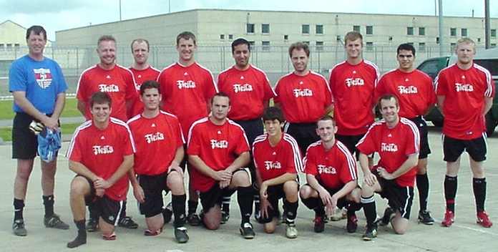
Match Analysis: Sports Quest entered the game full of confidence following a run of two successive victories over Beaumont’s FCI All-Stars. The traveling squad of fifteen players included four “rookies” making their debut on Beaumont soil. New boys Ryan Frommel, Richmond Whittington, Esteban Caro and Austin Teague were to learn very quickly that this was no ordinary soccer game. Much was at stake for both teams: Sports Quest looked to complete a hat-trick of wins against the previously unbeaten All-Stars (10 years), while Beaumont sought to erase the memories of the last 2 outings. The game plan for Sports Quest was simply to work hard for each other, not to be afraid of taking players on, and to accept every opportunity to test the opposition goalkeeper. Worryingly, the pre-game warm-up raised questions about the fitness levels of Sports Quest, with several players requiring “Time-outs” after a pedestrian game of “keep-away”…
The last time the teams met, Sports Quest struggled with the strength and stamina of the All-Stars, and the visitors had every reason to be concerned once again. Even more disconcerting was the hurricane-like conditions facing Sports Quest in the first half…A driving wind that was to prove frustrating to play against and difficult to overcome.
The 4-4-2 starting line-up included debutants Frommel and Whittington, and on the bench were Team Manager Jim Spence, prison ministry veteran Will Krasner, striker Caro, and the youngster Teague. Teague, in particular, was to come in for some “friendly” banter from the watching inmates; his stylish play making him a real crowd favorite!

The game started at a frantic pace, with early exchanges on each goal proving unsuccessful. The All-Stars threatened time and again using the wind as their ally. Goalkeeper Greg Malloch made a series of terrific saves, while the back line of Frommel, Miller (Matt), Whittington and Williamson (Chad) worked hard as a unit to keep the opposition at bay. In central midfield, Ortega and Gunzelman were pulling the strings, and out-wide, Frommel (Wesley) and Williamson (Jared) proved a handful to their defensive counterparts. Up front, the strike partnership of Albert and Miller (Mark) combined well on occasion, but the clinical finish failed to materialize. Albert’s 35th minute “goal” was disallowed because of an illegal challenge on the keeper, while at the other end, Beaumont missed a gilt edged chance from just two yards out. With the first 45 minutes completed, Sports Quest was surprised to see an additional 5 minutes added to game time. Eventually, the time clock ran down, and the teams finished the half level at 0-0.

Adopting an “up and at ‘em” attitude in the second half, Sports Quest pressed forward with the wind at their backs. An early, out of character close range miss from Mark Miller failed to dampen the spirits of Sports Quest, and in the 25th minute, Ortega and the impressive Teague combined to set up Caro to blast home from 6 yards. A third consecutive victory loomed large until the 90th minute when a valid call for offside was overruled by the assistant referee. Beaumont’s dubious equalizer stood in stark contrast to the spirit in which the game had been played. And worse was to come…another “mystery” five minutes of overtime appeared on the clock! The battle cry from both sets of players as well as the spectators was to go for the win. The mystery five minutes simply added spice to an already intriguing affair…
After hanging on for the first two minutes, Sports Quest made one final forage into the Beaumont half. A sublime pass from midfield saw Mark Miller receiving on the run with only the keeper to beat. As the seconds ticked away, he faked one way before sending the ball the other. A desperate dive from the keeper was to no avail as Miller’s shot clipped the inside of the post before rolling into the empty net. Two to one with less than a minute remaining, Beaumont pushed everyone forward looking to level the scores. Urged on by the sizeable home support, a darting forward run went untracked by central defenders Miller and Whittington, but out of nowhere, Team Manager Spence rolled back the years to intercept a certain strike on goal. Inspired by this selfless act of bravery, not to mention incredible burst of speed, his teammates rallied to withstand the ensuing threat on goal. The full-time whistle FINALLY brought to a close another memorable encounter between FCI Beaumont All-Stars and Sports Quest! Final score 2-1 to Sports Quest…
“Sharing God’s love and the message of salvation is at the heart of our excursions into Federal Correctional Institutions.”

The Bigger Picture: The game ended with handshakes all round, and a time of encouragement for the inmates. Seated around the center circle, a message of hope was clearly presented to both teams. Sports Quest explained that the mission and purpose of the visit to Beaumont goes beyond soccer. Sharing God’s love and the message of salvation is at the heart of our excursions into Federal Correctional Institutions. Team Chaplain, and Youth Pastor, Mark Miller emphasized the critical point that God does not require us to clean up our lives before coming to Christ. He only asks that we come to Him by faith….Admitting our sin and asking Jesus to take up residence in our heart and in our lives. He promises not only to live within us, but also to remain with us throughout this lifetime, as well as throughout eternity.

Inmates were challenged to trust Jesus Christ to become their Personal Lord and Savior…to give their life meaning, purpose and significance, no matter how much the past may accuse them of their unworthiness. It’s all about the One who died in our place…not our performance (or lack of) in life. By grace alone are we saved… (Ephesians 2:8-9).

“But God demonstrates his own love for us in this: While we were still sinners, Christ died for us.”
(Romans 5:8)

