Southwest Youth Athletics Association
www.swyouthathletics.com
southwestyaa@gmail.com
President Robert Lopez
Vice President Chris Pacheco
Secretary Deana Arnold-Gomez
Treasurer Sara Hernandez

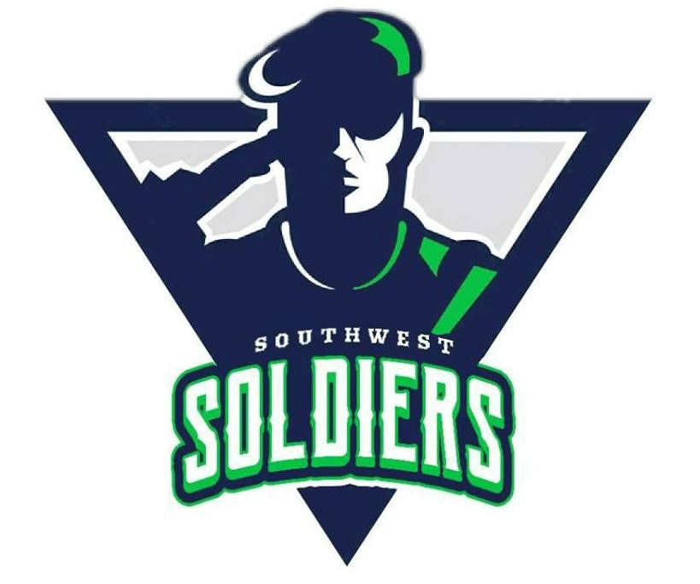

Sponsorship Letter

We would like to take this opportunity to invite you to become a part of our team for our Southwest Soldiers Football 2019 Season. Financial support from our community is one way to help our organization.

The Southwest Soldiers Football Organization program is designed to introduce, teach, and develop the fundamentals of Football to our local youth - as well as to promote good sportsmanship, teamwork and healthy competition. We feel this creates a valuable learning experience for the children of our community. The program also promotes self-esteem through teamwork.

The Southwest Soldiers Football Organization is a non-profit organization. Our funding is dependent upon the contributions of local businesses and individual donations, along with registration fees. All your generous donations are tax-deductible. Touch Down Club and Field Goal Club will receive their name displayed on our league website.

On behalf of all the children in this community who will benefit from your support of our program, the Southwest Soldiers Football Organization would like to thank you! Show your community spirit and join the CLUB!

Touch Down Club $500 and above
Field Goal Club $300 to $499
Safety Club $100 to $299
Extra Point Club All donations under $100

---------------------------------------------------------------------------------------------------------------------
I have enclosed my check payable to: Southwest Youth Athletics Association
Kindly acknowledge my donation by prominently displaying my name/company as follows:

Name of company/individual______________________________________________________

Mailing Address:______________________________ City : ______________Zip Code : _____

Business Phone: _____________________ Contact Person : ____________________________
Southwest Soldiers Football
For more Southwest Soldiers Football information contact:
Head Coach ___________________________or Team Mom ____________________________
Tax ID# 82-5440049

Donations of items, gift cards and food concession items are also welcome, they can be used for drawings and concessions sales to raise money.
Southwest Soldiers
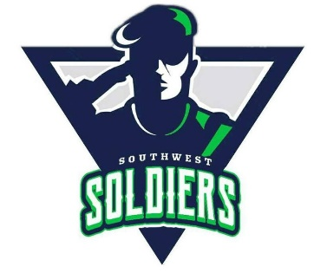
The Southwest Soldiers Football Organization is a non-profit organization that desires to make the sports experience safe, fun and beneficial for ALL children. We also encourage the significance of sports and other activities through academic, physical and mental development of youth. The Southwest Soldiers Football Organization believes that participation in sports and other activities cultivate imperative character traits and lifelong values. Below are some of the expenses our team will encounter this season. All fundraising, donations and sponsorship money will be placed into an account where All transactions are available for anybody to view
or examine.
TEAM EXPENSES:
Football Equipment
- Footballs (6) $200.00
- Water bottles $50.00
- Water Coolers $50.00
- Mouth Guards $30.00
- First Aid Kit $65.00
- Cones $80.00
- Hand Pump $5.00
- Football Needles $3.00
- Kicking Tees $10.00
- Decals $100.00
- Repair Kit $75.00
- Sideline Markers $200.00
- Chain Set $200.00
- Pylons $60.00
Uniforms
- Game Pants (30 pair) $900.00
- Game Jerseys (30) $2100.00
- Socks (30 pair) $150.00
Banquet $1000.00
- Trophies & Plaques $900.00
- Spring Picnic $500.00
Coaches Shirts $300.00

Total $6,978.00

