HEAD INJURY / CONCUSSION

Head injury is a broad tem that describes injury to the scalp, skull, brain, and tissues and blood vessels in the head. Some head injuries are also called brain injury, or traumatic brain injury (TBI), depending on the extent of the head trauma. Concussion is the most common type of TBI.

A concussion is caused by a blow or jolt to the head or body that causes the brain to shake. The shaking can cause the brain not to work normally and can result in serious side effects. If your child hits his/her head, be aware of the concussion symptoms to look for, which are commonly physical (such as a headache, nausea, or dizziness), sleep-related, difficulty concentrating or remembering, or involve mood disruption.

Initial treatment for a concussion is rest both mental and physical, which allows the brain time to heal. Every child’s injury and recovery is unique, but with guidance from a doctor your child can slowly return to school and play following a concussion.

Facts about concussions:
- All concussions are serious.
- Most concussions occur without loss of consciousness.
- Recognition and proper response to concussions when they first occur can help prevent further injury.
- When in doubt sit them out.

Head injury is a broad term that describes injuries to the scalp, skull, brain, and tissue and blood vessels in the child’s head. Some head injuries are Head

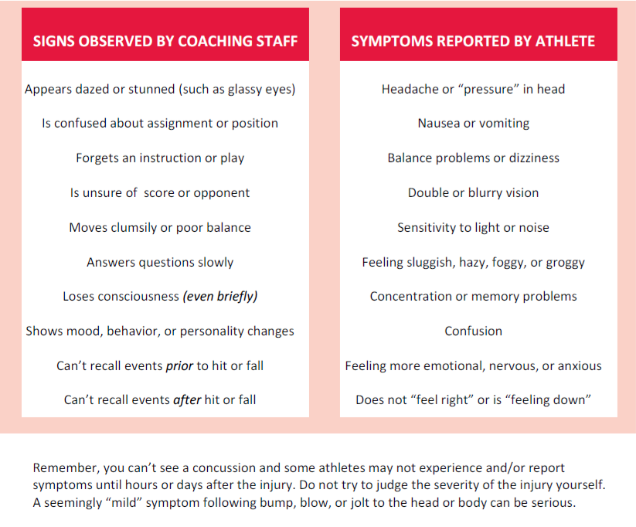
tissue and blood vessels in the child’s head. Some head injuries are also ca Suspect a concussion? Remove from play!
When concussions do occur, athletes should be removed from play and not return to sports until cleared by a medical professional familiar with concussion management. Children, especially adolescents and young teenagers, require longer recovery times and a more conservative treatment approach than adults.

Tips for Parents

If you suspect a concussion contact your child’s primary care physician for evaluation.

Concussions can occur even when a child does not lose consciousness. In fact, only 10% of children with concussions report being “knocked out.” Some of the symptoms of a concussion can appear immediately after the injury, while others may not show up for several days. Symptoms may last days, weeks or months. Sometimes symptoms may be subtle and not obvious.

What are the symptoms of a concussion?
The symptoms of a concussion are related to how well the brain cells are functioning and working together. The most common symptoms are:

Physical | Sleep | Thinking/  Remembering | Mood Disruption
- Headache  - Nausea and vomiting  - Balance problems  - Slowed reaction time  - Dizziness  - Sensitivity to light & sound  Fuzzy or blurry vision | - Sleeping more or less than usual  - Trouble falling asleep  - Feeling fatigued or drowsy | - Difficulty concentrating  - Difficulty remembering  - Confusion  - Feeling “mentally foggy”  - Feeling slowed down | - More emotional  - Irritable  - Sad  - Nervous  - Depressed

Often, symptoms will worsen over a matter of days, and it is common for new symptoms to appear in the days following the injury. Symptoms may also worsen when the brain is stressed, for example, when a child is doing schoolwork or participating in a physical activity.

Call 911 if your child has any of the following symptoms:
  - Seizures (twitching or jerking movement of parts of the body; may look stiff)
  - Weakness or tingling in the arms or legs
  - Cannot recognize people or places
  - Confused, restless or agitated
  - Impaired consciousness
  - Difficult to arouse or unable to awaken
  - Repeated vomiting
  - Slurred speech
  - Bloody or clear fluid from the nose or ears

Pre-existing conditions and concussion symptoms
For children with pre-existing conditions, such as migraine headaches, learning disabilities, attention deficit disorder (ADD), attention deficit hyperactivity disorder (ADHD), and emotional and mental health conditions, concussion symptoms may be more severe or prolonged. It is important to know that a concussion may also worsen these underlying conditions and make them more difficult to control

The information presented above consists of excerpts taken from the Children’s Hospital of Philadelphia published articles on Concussion Care for Kids: Minds Mater. The complete publication can be accessed at www.chop.edu/service/concussion-care-for-kids/concussion

